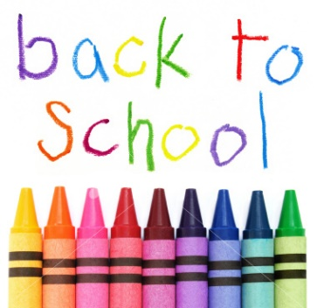

School Supplies 2022-2023

Toddlers
2 Boxes Tissues

Two Year Olds
1 8 pack Washable Markers
Large/Chubby Crayons

Preschool Threes
2 “Elmer’s Liquid Glue-All”
3+ Glue Sticks
1 Watercolor Paint Set
Wide Rule Spiral Notebook
1 Pack of 8 Washable Markers
1 box of 24 count crayons\
2 boxes of tissues
**Backpack

PreK Four-Fives
2 Boxes Tissues
Washable Markers (wide or thin)
3+ Glue Sticks
2 “Elmer’s Liquid Glue-All”
1 pkg Dry Erase Markers
1 8 pack Colored Pencils
1 Water Color Paint Set
1 box of 24 count crayons
Box of Ziploc Sandwich bags **Backpack

Extra’s (things we use a lot, we would appreciate any of these
you are able to bring)
· Dry Erase Markers
· Stickers
· Colored Cotton Balls
· Ziploc Bags (any size)
· Gallon Ziploc Bags
· Colored Copier Paper Ream

